4710A NE Stallings Drive Nacogdoches, TX 75965 Phone 936.205.5805 Fax 936.205.5997

Thank you for choosing LittleJacks Pediatrics! To make things a little easier we put together a list of things you will need to bring to your first visit. We want to ensure we have everything in order for you and your family to have the best visit possible. Immunization records are required in order to receive any vaccines.

- Insurance Card
- Driver’s License
- Immunization Records
- Names and dosages of any medication your child might be on or was on previously. List of any allergies, drug or otherwise.
- Name and fax number of your previous health care providers so we may request records.
- Custody orders/guardianship papers/adoption papers if you are not the biological parent.
Please review our Office Policies and Procedures for more information about our office.
If you have further questions please feel free to call. 936.205.5805

PATIENT REGISTRATION FORM
(Please Print)
Today’s date: |  |  |  |  |  |  |  |  |  |  |  |  |  |  |  |  |  |  |  |  |  |  |  |  |  |  |  |  | Primary Care Physician:

PATIENT INFORMATION
Patient’s last name: |  |  |  |  |  |  |  |  |  |  |  |  |  | First: |  |  |  |  |  |  |  |  |  |  |  |  |  | Middle: |  |  |  |  |  |  |  |  |  |  |  |  |  |  | Pharmacy:
If this is not, what is your legal name? |  |  |  |  |  |  |  |  |  |  |  | (Former Name?): |  |  |  |  |  |  |  |  |  |  |  |  | Social Security no.: |  |  |  |  |  |  |  |  |  |  |  |  | Birth date: |  |  |  |  |  | Age: |  | Sex:
 |  |  |  |  |  |  |  |  |  |  |  |  |  |  |  |  |  |  |  |  |  |  |  |  |  |  |  |  |  |  |  |  |  |  |  |  |  | / / |  |  |  |  |  |  |  | M | F
Guardian Home phone no.: |  |  |  |  | Guardian Cell phone no.: |  |  |  |  |  |  |  |  |  |  |  |  |  |  |  |  | Other phone no.: |  |  |  |  |  |  |  |  |  | Preferred contact method:
( ) |  |  |  |  | ( ) |  |  |  |  |  |  |  |  |  |  |  |  |  |  |  |  | ( ) |  |  |  |  |  |  |  |  |  | Home ph. Cell ph. Other ph. Work ph.
E-Mail Address:
Mailing address: |  |  |  |  |  |  |  |  |  |  |  |  |  |  |  |  |  |  |  |  | City: |  |  |  |  |  |  |  |  | State: |  |  |  |  |  | ZIP Code:
Referred to clinic by (please check one box): |  |  |  |  |  |  |  |  |  |  |  |  |  |  | Dr. |  |  |  |  |  |  |  |  |  |  |  |  |  |  |  |  |  |  |  |  |  |  |  |  |  | Insurance Company/Plan
Our Website |  |  | Other Webpage |  |  |  |  |  |  |  |  |  | Friend / Family |  |  |  |  |  |  |  |  |  |  | Yellow Pages |  |  |  |  |  |  | Newspaper |  |  |  |  |  |  |  |  |  | Other
Preferred language: |  |  |  | English Spanish Vietnamese Other (please specify):
Ethnicity: Hispanic Not Hispanic Race:

FINANCIAL INFORMATION
(Please give your insurance card(s) and identification card/driver’s license to the receptionist.)
Person responsible for bill: |  |  |  |  |  | Birth date: |  |  |  |  |  |  |  |  |  |  |  | Address (if different): |  |  |  |  |  |  |  |  |  |  |  |  |  |  |  |  |  |  |  |  |  |  |  | Home phone no.:
 |  |  |  |  |  | / / |  |  |  |  |  |  |  |  |  |  |  |  |  |  |  |  |  |  |  |  |  |  |  |  |  |  |  |  |  |  |  |  |  |  |  | ( )
Is this person a patient here? |  |  |  |  |  | Yes |  |  |  |  |  | No
Occupation: |  | Employer: |  |  |  |  |  |  |  |  | Employer address: |  |  |  |  |  |  |  |  |  |  |  |  |  |  |  |  |  |  |  |  |  |  |  |  |  |  |  |  |  |  | Employer phone no.:
 |  |  |  |  |  |  |  |  |  |  |  |  |  |  |  |  |  |  |  |  |  |  |  |  |  |  |  |  |  |  |  |  |  |  |  |  |  |  |  |  |  | ( )

INSURANCE INFORMATION
Is patient covered by insurance? |  |  |  |  |  |  |  | Yes |  |  |  |  |  |  |  |  | No |  |  | Primary Insurance Company:
Subscriber’s name: |  |  |  |  |  |  | Subscriber’s S.S. no.: |  |  |  |  |  |  |  |  |  |  |  |  |  |  |  | Birth date: |  |  |  | Group no.: |  |  |  |  |  |  |  |  |  |  |  |  |  |  | Policy no.:
 |  |  |  |  |  |  |  |  |  |  |  |  |  |  |  |  |  |  |  |  |  |  | / /
Patient’s relationship to subscriber: |  |  |  |  |  |  |  |  | Self |  |  |  |  |  |  |  |  |  | Spouse |  |  |  |  |  |  | Child | Other
Name of secondary insurance (if applicable): |  |  |  |  |  |  |  |  |  |  |  |  |  |  |  | Subscriber’s name: |  |  |  |  |  |  |  |  |  |  |  |  |  |  |  |  |  |  | Group no.: |  |  |  |  |  |  |  |  |  | Policy no.:
Patient’s relationship to subscriber: |  |  |  |  |  |  |  |  |  | Self |  |  |  |  |  |  |  |  | Spouse |  |  |  |  |  |  | Child | Other

IN CASE OF EMERGENCY
Name of local friend or relative to contact in an emergency: |  |  |  |  |  |  |  |  |  |  |  |  |  |  |  |  |  |  |  |  |  |  |  | Relationship to patient: |  |  |  |  |  |  |  |  |  | Home phone no.: |  |  |  |  |  |  |  |  |  | Work phone no.:
 |  |  |  |  |  |  |  |  |  |  |  |  |  |  |  |  |  |  |  |  |  |  |  |  |  |  |  |  |  |  |  |  |  | ( ) |  |  |  |  |  |  |  |  |  | ( )
The above information is true to the best of my knowledge. I authorize my insurance benefits be paid directly to the physician. I understand that I am financially responsible for any balance. I also authorize LittleJacks Pediatrics or insurance company to release any information required to process my claims.
 | Patient/Guardian signature |  |  |  |  |  |  |  |  |  |  |  |  |  |  |  |  |  |  |  |  |  |  |  |  |  |  |  |  |  |  |  |  |  |  |  | Date

LittleJacks Pediatrics Financial Policy and Authorizations

We are happy that you selected LittleJacks Pediatrics for your healthcare needs and look forward to working with you. To help you understand your financial responsibilities in relation to your medical care, we would like to briefly outline our financial policies.

Patients are expected to provide identification and if insured, a current insurance card(s) at time of service. Patients are financially responsible for all services provided and are expected to pay for services at time of service, including any past due balance from a prior date of service. If the patient is a minor child, the parent or other adult accompanying the child will be financially responsible regardless of legal guardianship. Returned checks will be subject to fees.

Medicare: The office will bill the Medicare intermediary. Patients are responsible for the following:
- Annual Medicare deductible
- All applicable co-pays of the allowed charge
- Any non-covered services
- Any covered service ordered by the physician which does not meet Medicare’s medical necessity and for which the beneficiary signed an Advanced Beneficiary Notice (ABN).

Medicare Supplemental and Secondary Insurances: The Practice will bill both Medicare and secondary insurances.

Medicaid: Patients must provide the Practice with a current Medicaid card at each visit. Medicaid patients are responsible for applicable co-pays and for all non-covered services. Medicaid patients are responsible for securing necessary referrals from their primary care physicians.

HMOs and PPOs, Commercial Insurance Plans: Patients are responsible for payment of the co-pay, co-insurance and/or deductible, or non-covered amounts at the time of service as well as for any charges for which the patient failed to secure prior authorization, if authorization is necessary. Insurance is filed as a courtesy and benefits are authorized to be paid directly to the Practice. Patients are responsible for the balance in full if not paid by the insurance within 30 days. If the patient is not prepared to pay the co-pay or deductible, a member of the clinical staff will determine if it is medically necessary for the patient to see the physician. If the patient’s condition allows, the appointment will be rescheduled.

Self-Pay: Patients are responsible for payment in full at the time of services for all services rendered.

Worker’s Compensation: Employer authorization must be obtained before treatment is rendered or the patient will be responsible for payment in full at the time of services for all services rendered. Once authorized, patients are not responsible for any charges unless the workers compensation case is dismissed or denied.

Personal Injury/Motor Vehicle Accidents and Other Third Party Liability: The patient is responsible for the balance in full at the time of service. Any settlement you receive from your insurance company or other third party will be handled by you, your insurance company, and/or your attorney.

Out of State Insurance: If the patient presents with an out of state HMO/PPO insurance card, we will need to verify the patient’s benefits for out-of-state or out-of-network benefits. The patient may be required to make payment in full or pay any co-pay, co-insurance or deductible.

Authorizations and Consent

ASSIGNMENT AND RELEASE: I hereby assign my insurance or other third party carrier benefits to be paid directly to the Physician Practice, realizing I am responsible for any resulting balance. I also authorize the Physician to release any information required to process this claim to my insurance carrier and/or to my employer or prospective employer (for employer sponsored/paid for claims). I acknowledge that I am financially responsible for services rendered, and failure to pay any outstanding balances may result in collection procedures being taken. Further, I agree that if this account results in a credit balance, the credit amount will be applied to any outstanding accounts of mine, or to a family member whose account I am guarantor for.

ELECTRONIC CHECK CONVERSION: When you provide a check as payment, you authorize us either to use information from your check to make a one-time electronic fund transfer from your account or to process the payment as a check transaction. When we use information from your check to make an electronic fund transfer, funds may be withdrawn from your account the same day.

CONSENT FOR TREATMENT: I hereby authorize the physicians, midlevel providers, nurses, medical assistants, and other Practice staff to conduct such examinations, and to administer treatment and medications as they deem necessary and advisable.

NO SHOW POLICY: I understand if I fail to come for a scheduled appointment or cancel at least 24 hours prior to the appointment, I will be considered a “no show” and may be subject to a “no show” charge per occurrence. Ongoing occurrences of no shows may result in dismissal from the Practice.

I understand the Financial and No Show Policies, Authorizations and Consent for Treatment, and hereby agree to them:

______________________________________________ __________________
Patient or Parent/Guardian if Minor Date 2-23-2007; Rev 2-13-15; Rev 8-1-15

Patient Portal Informed Consent & User Agreement
Patient Portal

LittleJacks Pediatrics offers its patients the use of a secure web-based Portal which provides you with secure electronic access to your medical record and communications between our office and you. To use the Portal you must agree to the Portal policies and procedures by signing the Informed Consent and User Agreement, and by activating your Portal account. Our Practice staff will enroll you and provide you with a confidential “token” and instructions on how to complete your enrollment. Your “token” is your access code to the Portal and will no longer be needed after activation. If unused, it will expire within in 30 days.

Portal Risks and Precautions

Secure messaging can be a valuable communications tool, but certain precautions should be used to minimize risks. Your signature on this form will document that you have been informed of and accept these risks and agree to the conditions of participation.

Privacy Protection of your Health Information

All messages sent to you will be encrypted to keep unauthorized persons from accessing your information. Keeping information secure depends on two factors: the secure message must reach the correct email address and only the correct individual (or someone authorized by the individual) must have access to it. While the likelihood of risks associated with the use of Portal is substantially reduced, there are risks which are important for you to understand. By signing this consent agreement you agree you will follow prudent security measures when you access the Portal and will communicate in a manner that reduces the likelihood of these risks occurring including but not limited to:

- Never use a public computer to access the Portal
- Do not store, send or access messages on your employer-provided computer or hand-held device as information is normally accessible by your employer
- Use a screen saver or close your messages so that others nearby cannot read them
- Keep your username and password safe and private
- If you are accessing the Portal via your mobile handheld device, you should password protect your device in the event your device is lost and/or stolen
- If you think someone has learned your password, you should promptly change it using Portal
- You are responsible for updating your contact information with the Practice any time it changes including the email address you designate for Portal or outside Portal messenging
- If you receive access to health care information which is not yours, immediately stop viewing such information and notify the Practice via a secure message on the Portal or by phone call

Access, Use of Online Communications and Conditions of Participation

- Use of Portal is limited to non-emergency communications and requests
- In an emergency, call 911 or go to the nearest Emergency Room
- The Portal does not provide online medical advice, or replace the services of your provider
- A diagnosis can be made and treatment rendered only after your provider sees you
- You may view educational resources on various topics listed in the Portal library
- You may view a clinical summary of your most recent office visit as well as lab and test results
- You may send messages to your provider or staff, and you may view and respond to messages they send to you. All communications will be included in the clinical record maintained by the Practice
- Communications regarding sensitive subject matters such as mental health, HIV, clinical research, employer-related services, etc., are not permitted through the Portal
- When using the Portal please be concise. Confirm that your name and other personal information in a message is correct, and review before sending to make sure it is clear and all relevant information is included
- Your provider or staff, in their judgment, may decline to respond to a communication, and may ask you to call or to schedule an appointment at the office concerning the matter
- Access to the secure web Portal is a service, and we may suspend or discontinue at any time and for any reason
- Messages will be reviewed during normal hours of operation and every attempt will be made to respond to your messages within 48 business hours

Please see our Notice of Privacy Practices for additional information on privacy of your health information.

*Minors or Users Requiring Caregivers – Acknowledgement of Portal Access to My Health Information to the Following Individual:

Name: _____________________________________ Date of Birth: _________________
Relationship to Patient: _______________________________
Address: ________________________________________________________________
Email Address: __________________________________________________________
Signature: _____________________________ Date:__________________________
_________Parent/Guardian agreement to waive my right to the above minor’s Portal and allow (initials) him/her to be treated as an adult for Portal enrollment and access.

A federal law was passed in 2014 and became effective on September 30, 2014, governing how we may contact you via telephone, text, and email. Listed below are some of the reasons we may need to contact you via telephone, text, or email:
- Appointment reminders
- Follow up with test results
- Reminder calls about annual preventive care due
- Email or fax with patient forms to complete prior to your appointment
- Notification of medication renewals
- Notification of surgery time and date
- Notification of prepayments for surgeries and procedures
- Follow up calls after surgeries or procedures
Consent to Contact

By providing a telephone number, I expressly consent and authorize the physician practice, any practitioner or clinical provider as well as any of their related entities, agents, or contractors, including but not limited to schedulers, marketers, advertisers, debt collectors, and other contracted staff (collectively referred to herein as “Provider”) to contact me through the use of any dialing equipment (including a dialer, automatic telephone dialing system, and/or interactive voice recognition system) and/or artificial or prerecorded voice or message. I expressly agree that such automated calls may be made to any telephone number (including numbers assigned to any cellular or other service for which I may be charged for the call) used by, or associated with me and obtained through any source including, but not limited to, any number I am providing today, have provided previously or may provide in the future in connection with the medical goods and services and/or my account. By providing this express consent, I specifically waive any claim I may have for the making of such calls, including any claim under federal or state law and specifically any claim under the Telephone Consumer Protection Act, 47 U.S.C. § 227. By providing a telephone number, I represent I am the subscriber or owner or have the authority to use and provide consent to call the number.

By providing a telephone number, I expressly consent to the receipt of text messages from Provider at any telephone number (including numbers assigned to any cellular or other service for which I may be charged for the call) used by, or associated with, me and obtained through any source including, but not limited to, any number I have provided previously or may provide in the future in connection with my account. By providing this express consent, I specifically waive any claim I may have for the making of such calls, including any claim under federal or state law and specifically any claim under the Telephone Consumer Protection Act, 47 U.S.C. § 227. By providing a telephone number, I represent I am the subscriber or owner or have the authority to use and provide consent to call the number.

By providing my email address now or at any time in the future in connection with the medical goods and services provided and/or my account, I expressly opt-in to the receipt of email communications from Provider for or related to the medical goods or services provided, my account, and other services such as financial, clinical and educational information including exchange news, changes to health care law, health care coverage, care follow up, and other healthcare opportunities, goods and services. By providing this express consent, I specifically waive any claim I may have for the sending of such emails, including any claim under federal or state law and specifically any claim under the CAN-SPAM Act, 15 U.S.C.§ 7701, et seq. By providing an email address, I represent I am the subscriber or owner or have the authority to use and provide consent to contact the email address.

I understand that providing a phone number and/or email address is not a condition of receiving medical services. I also understand that I may revoke my consent to contact at any time by directly contacting Provider or utilizing the opt–out method that will be identified in the applicable communication.

I have read and understand the above and consent to contact as described:

Patient Name: _______________________________ Date of Birth: ______________________
Signature: _______________________________ Date:______________________________
*Minors or Users Requiring Caregivers – Acknowledgement of Consent to Contact

Name: _____________________________________ Relationship to Patient: _______________
Signature: _______________________________ Date:______________________________
NOTICE OF PRIVACY PRACTICES (NPP) ACKNOWLEDGEMENT
A Notice of Privacy Practices (NPP) is provided to all patients and explains: (1) how your Protected Health Information (PHI) may be used or shared; (2) your rights to access or amend your PHI, request information on disclosures of your PHI, and request additional restrictions on our uses and disclosures of PHI; (3) your rights to complain if you believe your privacy rights have been violated; and (4) our responsibilities for maintaining the privacy of your PHI.

- I acknowledge that I have received a copy of the “Notice of Privacy Practices” (Version 3 August 2013 dated 09/23/2013) that explains when, where, and why my Protected Health Information (PHI) may be used or shared.
- I authorize LittleJacks Pediatrics to furnish complete information, including Protected Health Information, requested by my insurance carrier or its intermediaries regarding services rendered. I hereby authorize my insurance carrier to furnish to LittleJacks Pediatrics any information obtained in the adjudication of any claim for services furnished to me by LittleJacks Pediatrics.
- I acknowledge that LittleJacks Pediatrics, the physicians, the nurses, and other staff may obtain and share any or all of my Protected Health Information, including prescription history, with other health care professionals in order to treat me, coordinate my care, and/or in order to arrange for payment of my bill and respond to any issues related to my care.
- I acknowledge that I have the right to request additional restrictions on the use and disclosure of my PHI if I so choose.
Name of Patient/ or Guardian (if Minor): __________________________________________________________
Signature of Patient/or Guardian: _______________________________________________________________
Date: ____________________

PATIENT COMMUNICATION CONSENT
We may need to contact you regarding your medical care. This is to acknowledge that you authorize LittleJacks Pediatrics to (check all that apply):
□ Leave a detailed message on voice mail/machine
□ Call my workplace phone number and leave a message
□ Call my workplace phone number and speak only to me
□ Transmit and Receive messages through Patient Portal (NextMD or Other) including secure email
□ None of the above

I further authorize the disclosure of my PHI to the following individuals or family members:

Name: ________________________________________ Relationship to Patient:_________________________

Name: ________________________________________ Relationship to Patient: _________________________

Name: ________________________________________ Relationship to Patient:_________________________

Signature of Patient/Guardian: ___________________________________________ Date: ____________________

****Please list your children’s Names and Dates of Birth****
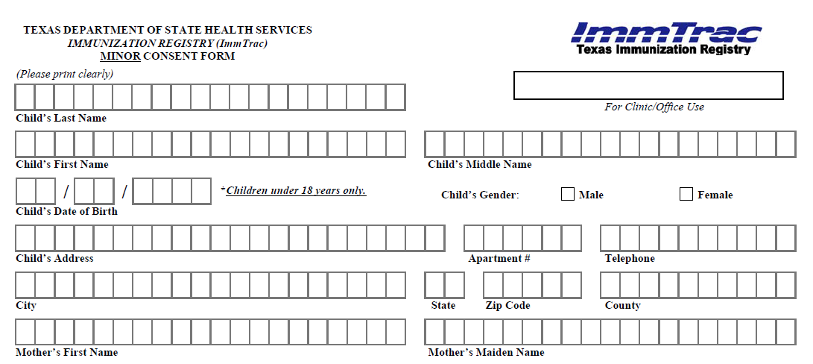
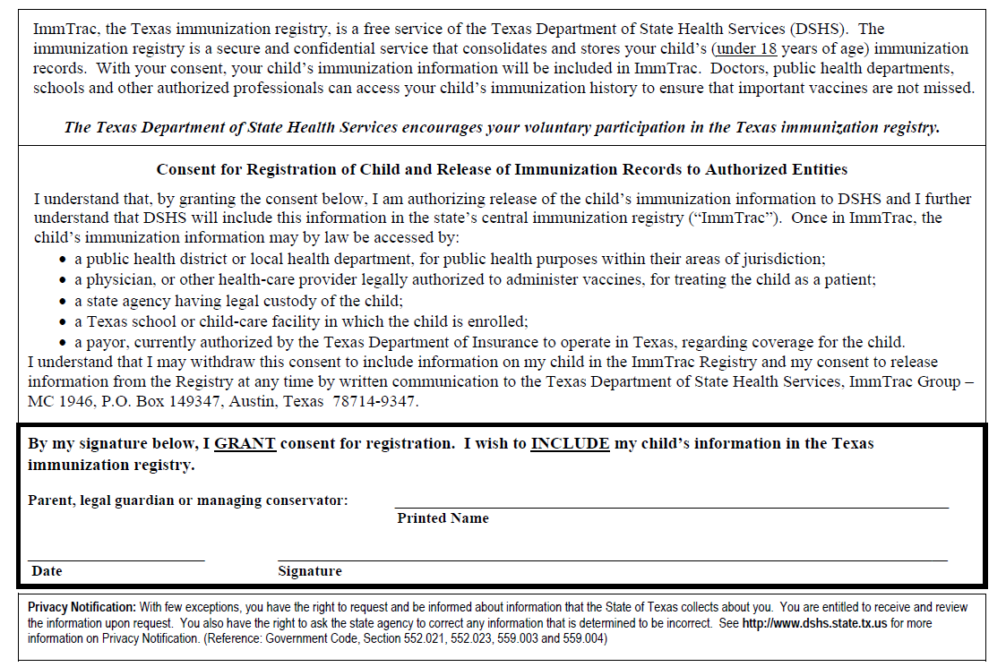
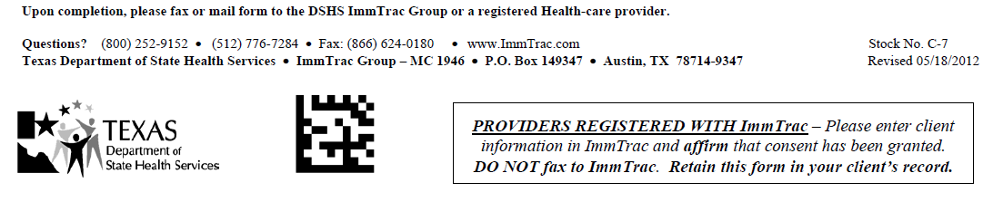
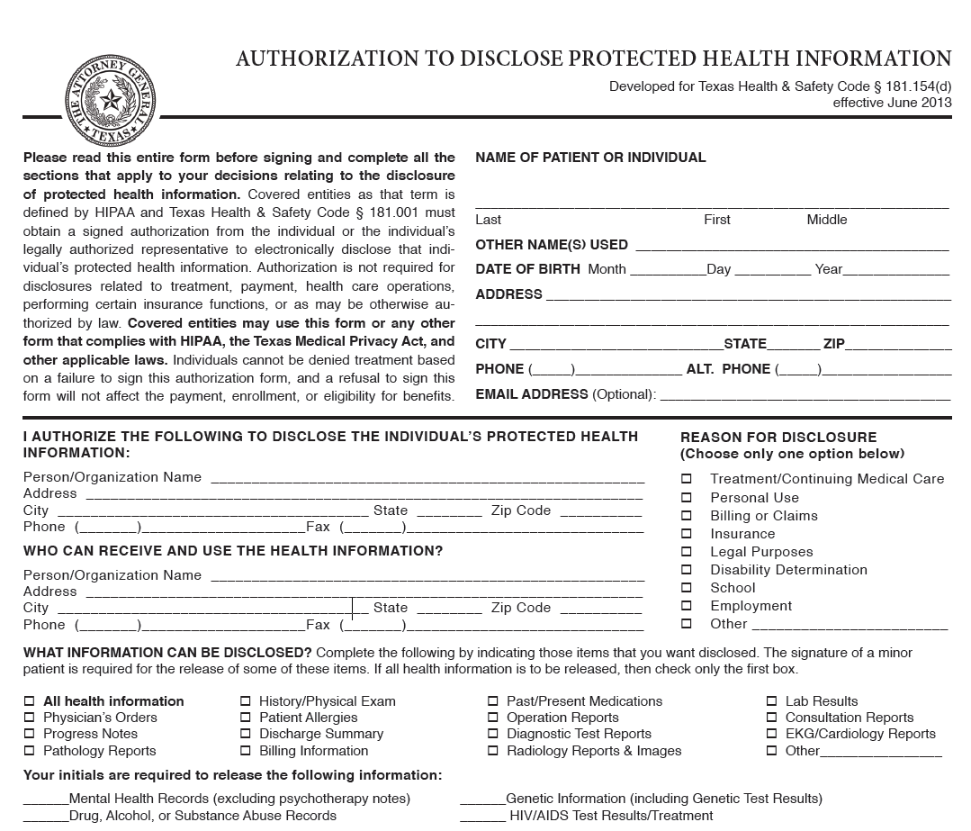
If records are more than 50 pages please mail!!
936 205-5805 936 205-5997
TX 75965
Nacogdoches
4710A NE Stallings Drive
LittleJacks Pediatrics

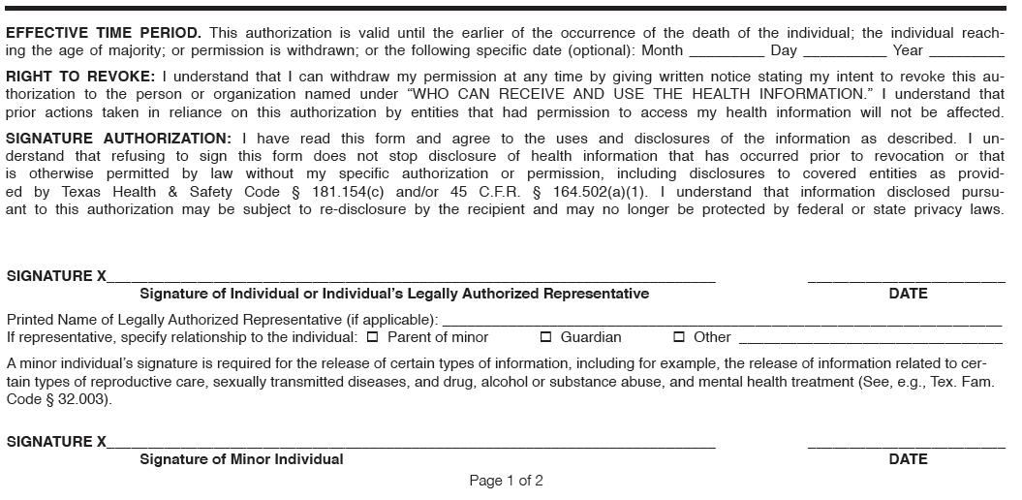

LittleJacks Pediatrics Office Policies
Welcome and thank you for choosing LittleJacks Pediatrics. We appreciate the opportunity to provide your child with the highest quality pediatric care available. Here are some helpful tips for your first visit at LittleJacks Pediatrics. We understand how cumbersome completing paperwork at a new physician's office can be. We have included our necessary paperwork for you to download (under Forms at LittleJacksPediatrics.com). Please print and complete at home to help your first visit be more comfortable. Do not hesitate to call our office with questions.
- Please arrive 15 minutes prior to your scheduled appointment to provide administrative time to update your registration information prior to seeing the provider.
- Remember that a parent, legal guardian, or Consent Proxy must be present with the child at all office visits.
- Bring all insurance cards that provide coverage for your child.
- Bring your child's immunization record.
- Co-payments are collected upon arrival. Refer to your insurance card for office co-payment amount.
Sick & Well Entrances
We offer separate sick and well reception areas. We ask that you limit the number of guests that accompany you and your child on an office visit. Seating is limited in our reception area and your guests might be exposed to illnesses.
Please do not leave children unattended in the reception areas.
If you suspect your child is ill to any degree please be considerate and keep your child in the sick reception area. If you think your child has chicken pox and needs to be seen, please discuss entry into the facility with staff prior to coming in.
We keep a limited amount of toys in the reception areas because they are not practical with the many sick children we see throughout the day. The risk of transmission of germs is too great. We tidy up and disinfect our reception areas twice a day. We encourage you to bring your child's favorite books or small toy to help them be entertained and more comfortable during the visit. We also provide TV viewing in both our sick and well waiting rooms.
Sick and Well Visits
The appointment time for sick children is shorter than for well child visits. If your child is already scheduled for a well visit but happens to be sick we can usually still do the check-up. If your child is scheduled for a sick visit we usually do not have time that day to do a full check-up.

Missed or Cancelled Appointments
Check-up and Consultation appointments that are missed or not cancelled within 24 hours of the scheduled appointment time will be documented. If there are consistent no shows you will likely be dismissed from our care.
Your appointment time is reserved exclusively for you and your Child. Please be considerate of others - if you miss your appointment or cancel at the last minute, we will be unable to care for another patient in your child's place. As a courtesy, we make appointment reminder calls.
We do not book as many patients as possible into our appointment schedule. At our Practice, we believe that we can provide optimal Pediatric care only if we have enough time set aside to adequately examine your child, discuss your child’s condition and treatment options in detail with you. This requires that you arrive on time for your appointment. If you are more than 15 minutes late for your appointment, we may not be able to accommodate you, and we may need to reschedule your visit. If you think that you will be late for your appointment, please call us as soon as possible, so that we may advise you if your late arrival can be accommodated, or if we will need to reschedule you.
Add On Sibling Sick Visits
Our schedule allows for several work-in slots every day to accommodate our patient’s needs. If you have a scheduled sick visit for one child and feel another child in your family needs to be seen, please call ahead so we can review the practitioners schedule to make sure the time is available.

Appointments

If you no show to more than 3 appointments we will evaluate our need to discontinue our professional relationship with you and your child, at which point we will request you find a new physician.

We see our patients by appointment so we can see your child with the least wait time. We will always see your child if necessary. We will make every effort to see your child on time, because we know your time is as valuable as ours. Below are some suggestions and guidelines that will help you to understand our systems and allow us to serve you more effectively.
Should we have an emergency and are unable to see you as scheduled, we will let you know as soon as possible so you can have the option to reschedule the appointment. Other situations that cause the wait to be longer:
- illness that requires extra time
- scheduling errors- patient goes to wrong location
- patients are late or add another child at the office
- walk-in patients with emergent issues
As hard as we try, we cannot always predict the needed amount and/or duration of appointment times correctly. The volume and degree of illness is not always predictable. You can help us schedule the appropriate appointment time for your child by giving our staff the purpose of the visit, and the specific nature of your concerns. Please mention if you want tests performed or discussed at the visit.

Chronic Conditions / Consultations
If your child has a chronic, ongoing situation we may need to schedule a longer, consultation type appointment. Examples: headaches, stomach problems, behavior concerns, new patient with a chronic illness (asthma, diabetes). Please leave a message for our advice line to call you back and discuss the situation so we can book the appointment appropriately.

Phone Calls
We receive many calls each day, and we do our best to answer each call as quickly as possible. We take questions regarding appointments, prescription refills, insurance, etc. during normal office hours. Here are some tips to help you save time.
- Tell the receptionist briefly what you need, an appointment, talk with a Nurse; check on test results, etc.
- Any questions that can wait until your child’s routine checkup please write down and bring with you to the checkup appointment.
- To minimize delays in processing your non-urgent calls, avoid our busiest hours, which are early morning and after school. You may experience more difficulty getting through on Monday and Tuesday
- You may be asked if you can wait on hold. If this is not convenient, please tell the receptionist that you will call back later.

Phone Options- Press 1 for Address and Fax
Press 2 If you are a Physician or Pharmacy
Press 3 for Scheduling
Press 4 for Nurse Line
Press 5 for Billing
Press 6 for Medical Records
Medical Questions Line
Our staff has been trained to handle many of your questions and will be happy to assist you. They can help you decide if your child needs to be seen in the office or if there is something you might try at home first. If your child is ill please take her/his temperature so we can help you more quickly. Our goal is to return messages within one hour. Occasionally, during peak periods we may prioritize calls by urgency and return non-urgent calls within four hours. We will attempt to return all calls at least three times by the end of the day. If you do not receive a return call from us within a reasonable amount of time, please call us back.
If your question requires the attention of a practitioner you will need to leave a detailed message on extension 3 for our nurse. The nurse will relay all pertinent information to a provider and then give you a call back with medical advice.
Our Medical Questions Line staff also assists parents with referrals to specialists and/or for outside testing.
Patient Portal Online
Our office provides secure communication through Patient Portal email for non-urgent advice. Please ask us about signing up for Patient Portal upon your first visit. If you do not receive a response by the end of the next business day please call our office.

After Hours and Emergencies
If you believe you have a life threatening emergency dial 911 or go to the nearest emergency room.
If your issue is non-urgent you will need to reach the office during business hours.

Most insurance plans offer a 24 hour nurse line for medical advice. Most often you can find that number on the back of your insurance card.

Medical Records
New patients should bring copies of their prior medical records including immunization records for their first visit with our practice. We will enter the data and scan the records into your child’s Electronic Health Record and return the paper copies to you.
If your child receives care out of town or after hours from another practitioner, please bring a copy of the visit, or ask them to mail / fax a copy so we can keep your child's medical record complete.
As we see your child for well care we will provide you with an update on your child’s immunization records and growth and development data. This record is important to keep at home. From time to time you may need these records when our office is not available. Your child’s medical records are maintained with strict adherence to patient confidentiality laws. You may, with a written, signed request, obtain copies of your child’s medical records. Whether the copy is for you or for another physician we will forward the records, a reasonable number of times, at no charge. We usually require 10 business day notice to prepare your records. We recommend you pick up your records and take them to your new physician if you are moving.
Form Policy
At some point you will likely require a form to be completed for your child. We request that you bring these forms to your child's well visit, and we will be happy to complete them free of charge.
In addition as a result of HIPPA regulations, we require a singed release of information in order to complete these forms. We appreciate your patience as we complete your forms.
Please allow us 3-5 business days. Once completed, we can have the forms available for you to pick up at the office or we can return the forms to you by mail (with a self-addressed stamped envelope) or by fax.

Refills & Test Results
If you need a refill, you need to call your pharmacy and request one. They will electronically transmit the request and we will approve the refill at that time. If you need to discuss a medication change you need to leave a message on the Medical Questions Line and wait to be advised if we need to schedule a face to face visit in the office. If the face to face is not necessary we will electronically transmit your child’s prescription to the pharmacy.
If we receive abnormal findings on any lab work that we have ordered you will receive a call to discuss the findings and any course of action that may need to be taken.
Services and beeper companies are not flawless. If your after-hours call is not returned in a reasonable amount of time, please call the service back and let them know this is the second time you have called.
Referral To Specialists / Testing
We can help you find a specialist and/or an outside testing facility and will work closely with them to care for your child's needs. Our practitioners will help you decide when a specialist or outside testing is necessary.
It is your responsibility to know if you need a referral and the time requirements. Most insurance cards have the information on the back of the card or a phone number you can call to find out the information.

